Room Hire @ Lancaster Centre, Enfield, EN2 0BU

[www.lancaster-centre.co.uk](http://www.lancaster-centre.co.uk/)

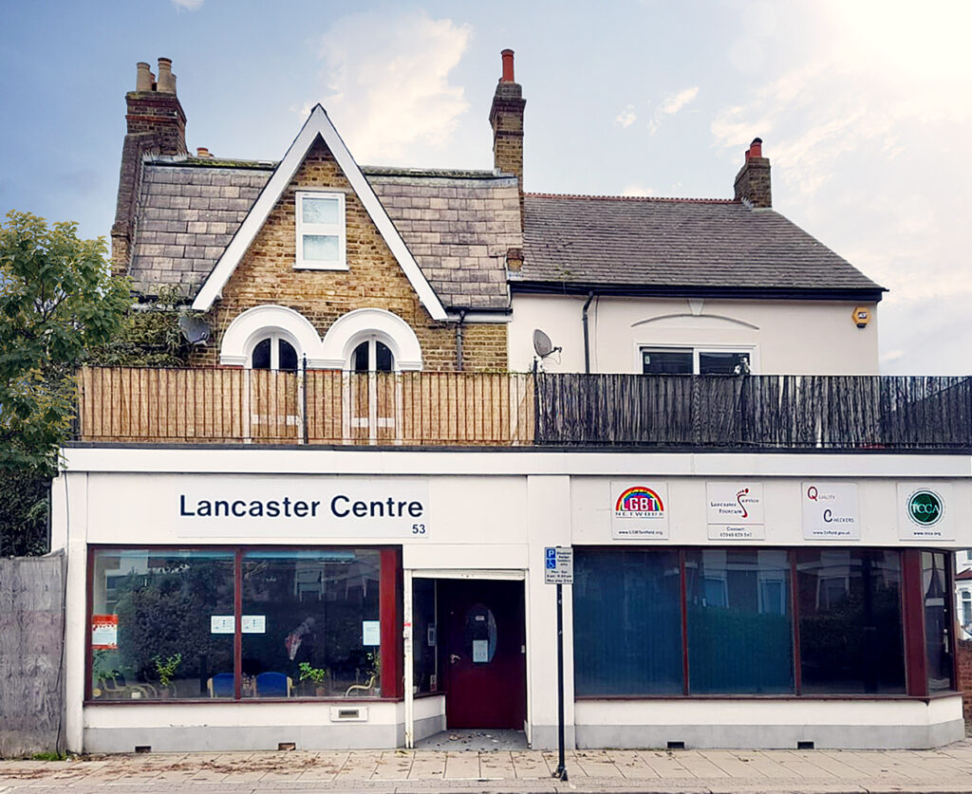

Date of booking request: ____________________

**Date or dates required:** ________________________________

*Please indicate which session(s) below.*

|  |  |  |
| --- | --- | --- |
| Morning:  09:00 to 13:00 | Afternoon:  13:00 to 17:00 | Evening:  17:00 to 21:00 |
|  |  |  |

*For evening bookings only*, please specify the time that you require access: Start ____________ Finish ___________

**Room/s required:** *Please indicate which room or rooms below.*

|  |  |  |
| --- | --- | --- |
| Conference Room | Sitting Room | Counselling Room |
|  |  |  |

**Do you require a receptionist? (evenings and weekends only) ____**

**Contact Name:** ________________________________

**Telephone Number:** __________________________

**Email Address:** __________________________

**Name of Organisation:** _______________________

**Billing email address (if different):** _______________________

**Conditions of Room Hire**

* *Lancaster Centre strives to be an* ***Equal Opportunity*** *community service provider. This means that any community activities that are held at the Centre must* ***be inclusive****.*
* *As part of our commitment to the above, you may be required to submit your* ***Equal Opportunities Policy*** *when booking a room.*
* *All groups are required to undertake appropriate risk assessments for their service.*
* *Each four-hour session* ***includes*** *your set-up and clear-up time.*
* *Dirty dishes must be neatly stacked in the dishwasher and turned on when full.*
* *Each room* ***must be left*** *in the condition you would like to find it. Cleaning equipment is available in the cleaning cupboard.*
* *There is a* ***£50 penalty charge*** *for not leaving the room in a reasonable condition.*
* *Bookings cancelled with* ***less than five working days’*** *notice will be charged at the full rate and are* ***non-refundable.***

***I have read, understood and agree to the Lancaster Centre’s conditions of room hire stated above.***

**Signed:** __________________________

Please complete and return this form to Mark Riley via the email address: mark@LGBTenfield.org

07706 453845